**PROFESSIONAL TRAINING REPORT**

**At**

**Sathyabama Institute of Science and Technology** (**DEEMED TO BE UNIVERSITY**)

Submitted in partial fulfillment of the requirements for the award of

Bachelor of Engineering Degree in

Computer Science and Engineering

By

**CHIMAKURTHI PRAVEEN (Reg. No. 36110251)**



**DEPARTMENT OF COMPUTER SCIENCE AND ENGINEERING**

**SCHOOL OF COMPUTING**

**SATHYABAMA INSTITUTE OF SCIENCE AND TECHNOLOGY**

**JEPPIAAR NAGAR, RAJIV GANDHI SALAI,**

**CHENNAI – 600119, TAMILNADU**

**JUNE 2018**



**SATHYABAMA**

**INSTITUTE OF SCIENCE AND TECHNOLOGY**

**(DEEMED TO BE UNIVERSITY)**

**Accredited with Grade “A” by NAAC**

**JEPPIAAR NAGAR, RAJIV GANDHI SALAI, CHENNAI - 600 119**

**www.sathyabama.ac.in**

**_________________________________________________________________**

**SCHOOL OF COMPUTING**

**BONAFIDE CERTIFICATE**

This is to certify that this Professional Training Report is the bonafide work **CHIMAKURTHI PRAVEEN** (**Reg.No.36110251**) who underwent the professional training in “**RAIN DETECTION BASED ALERT SYSTEM”** under our supervision from May 2018 to June 2018.

**Internal Guide**

**Mrs. D.USHA NANDINI**

**Head of the Department**

**Dr. S.VIGNESHWARI**

**Submitted for Viva voce Examination held on_____________________**

**Internal Examiner External Examiner**

**DECLARATION**

I, **CHIMAKURTHI PRAVEEN** (**Reg.No.36110251**) hereby declare that the Professional Training Report on “**RAIN DETECTION BASED ALERT SYSYTEM”** done by me under the guidance of guide **Dr. D. USHA NANDINI** professor, Dept of Biotechnology at Sathyabama Institute of science and technology is submitted in partial fulfillment of the requirements for the award of Bachelor of Engineering degree in Computer Science and Engineering.

**DATE:**

**PLACE:** **SIGNATURE OF THE CANDIDATE**

**ACKNOWLEDGEMENT**

I am pleased to acknowledge my sincere thanks to Board of Management of **SATHYABAMA** for their kind encouragement in doing this project and for completing it successfully. I am grateful to them.

I convey my thanks to **Dr. M. Lakshmi, M.E., Ph.D., Dean,** School of Computing and **Dr. S. VIGNESHWARI Head of the Department, Dept. of Computer Science and Engineering** for providing me necessary support and details at the right time during the progressive reviews.

I would like to express my sincere and deep sense of gratitude to my Project Guide **Dr. D.USHA NANDINI** for his valuable guidance, suggestions and constant encouragement paved way for the successful completion of my project work.

I wish to express my thanks to all Teaching and Non-teaching staff members of the Department of **Computer Science and Engineering** who were helpful in many ways for the completion of the project.

**TRAINING CERTIFICATE**



**ABSTRACT**

Water is basic need in every one’s life. Saving and proper usage of water is very important. Here is an easy project which will give the alarm when there is rain, so that we can make some actions and save the rain water. As a result, we can increase the water levels of underground water by using underwater recharge technique. Rain water detector will detect the rain and make an alert; rain water detector is used in the irrigation field, home automation, communication, automobiles etc. Here is the simple and reliable circuit of rain water detector which can be constructed at low cost

Rain water sensor is the main component in the circuit. For this rain sensor, no need to go and buy in the market or online. We can do it ourselves just by taking the piece of Bakelite or mica board and aluminum wire. Bakelite or mica board should be made completely flat and aluminum wire should be pasted on the flat board as shown in the figure below of rain water sensor. Care should be taken that there should be no spaces between the wire and board. When the rain water sensor is completed, it should get connected to the circuit and voltage should be passed through the wires.

**TABLE OF CONTENTS**

|  |  |  |
| --- | --- | --- |
| **CHAPTER**  **NO.** | **TITLE** | **PAGE**  **NO.** |
| **1** | **INTRODUCTION** | **1** |
|  | 1.1 INTERNET OF THINGS | 1 |
|  | 1.2 OVERVIEW OF THE PROJECT | 2 |
|  | 1.3 OBJECTIVE OF THE PROJECT | 2 |
| **2** | **SYSTEM ANALYSIS** | **4** |
|  | 2.1 EXISTING SYSTEM | 4 |
|  | 2.2 PROPOSED SYSTEM | 4 |
| **3** | **PROJECT DESCRIPTION** | **6** |
|  | 3.1 ARCHITECHTURE DIAGRAM | 6 |
|  |  | 7 |
|  | 3.2 FEASIBILITY STUDY | 7 |
|  | 3.2.1 ECONIMICAL FEASIBILITY | 7 |
|  | 3.2.2 TECHNICAL FEASIBILITY | 8 |
|  | 3.2.3 OPERATIONAL FEASIBILITY | 8 |
| **4** | **SYSTEM SPECIFICATIONS** | **9** |
|  | 4.1 HADWARE ENVIRONMENT | 9 |
|  | 4.2 SOFTWARE ENVIRONMENT | 10 |
|  | 4.3 AURDINO EVOLUTION  4.3.1 PIN SPECIFICATION | 16 |
|  |  | 17 |
| **5** | **MODULES** | **18** |
|  | 5.1 MODULES | 18 |
|  | 5.2 MODULES DESCRIPTION | 18 |
|  | 5.2.1 SERVER | 18 |
|  | 5.2.2 HARDWARE SETUP | 19 |
| **6** | **APPENDIX** | **20** |
|  | 6.1 SCREEN SHOTS | 20 |
|  | 6.2 SOURCE CODE | 22 |
| **7** | **CONCLUSION** | **25** |
| **8** | **REFERENCES** | **26** |

**CHAPTER 1**

**INTRODUCTION**

**1.1 IOT (INTERNET OF THINGS)**

## What is the Internet of Things?

In a nutshell, the Internet of Things is the concept of connecting any device (so long as it has an on/off switch) to the Internet and to other connected devices. The IOT is a giant network of connected things and people – all of which collect and share data about the way they are used and about the environment around them.

## How does it work?

Devices and objects with built in sensors are connected to an [Internet of Things platform](http://www.ibm.com/internet-of-things/), which integrates data from the different devices and applies analytics to share the most valuable information with applications built to address specific needs.

These powerful IOT platforms can pinpoint exactly what information is useful and what can safely be ignored. This information can be used to detect patterns, make recommendations, and detect possible problems before they occur.

For example, if I own a car manufacturing business, I might want to know which optional components (leather seats or alloy wheels, for example) are the most popular. Using Internet of Things technology, I can:

* Use sensors to detect which areas in a showroom are the most popular, and where customers linger longest;
* Drill down into the available sales data to identify which components are selling fastest;
* Automatically align sales data with supply, so that popular items don’t go out of stock.

The information picked up by connected devices enables me to make smart decisions about which components to stock up on, based on real-time information, which helps me save time and money.

With the insight provided by advanced analytics comes the power to make processes more efficient. Smart objects and systems mean you can automate

certain tasks, particularly when these are repetitive, mundane, time-consuming or even dangerous.

**1.2 OVERVIEW OF THE PROJECT**

Water is a basic need in every one’s life. Saving water and proper usage of water is very important. Here is an easy project which will give the alarm when there is rain, so that we can make some actions for rain water harvesting and also save the rain water for using it later.

With the help of saving this rain water through rain water harvesting, we can increase the levels of underground water by using underwater recharge technique.

Rain water detector will detect the rain and make an alert; rain water detector is used in the irrigation field, home automation, communication, automobiles etc. Here is the simple and reliable circuit of rain water detector which can be constructed at low cost

**1.3 OBJECTIVE OF THE PROJECT**

To  build a circuit that detects rain and can shut power off to a sprinkler system whenit is raining. INTRODUCTION Benefits of Water ConsumptionOne benefit is energy conservation. Water-pumping, delivery, and wastewater-treatment facilities consume a significant amount of energy. In some regions of the world over 15 percent of total electricity consumption isdevoted to water management. Saving water conserves this energy for other uses. Another benefit is habit at conservation. Overuse of fresh water can lower the levels of lakes and rivers, causing significant environmental problems. Minimizing human water use helps preserve freshwater habitats for local wildlife and migrating waterfowl, as wellasreduces the need to build new dams and other water-diversion infrastructures.There are few things as wasteful as a water sprinkler system running during a rainstorm. The goal of this environmentalengineering science project is to build anelectronic circuit that can detect when it is raining and that can shut off thepower toan automatic sprinkler system

The project “Rain detection with automatic closing of window ” was designed to control the window automatically based on the rain sensor detection. Rain operated motor was designed based on conduction sensor (Tough sensor) circuit, Control Unit, stepper motor . The sensor was used to detect the rain or water flow. Therefore when it senses window closes automatically & opens when it is not in contact with rain or water flow.

.

**CHAPTER 2**

**SYSTEM ANALYSIS**

**2.1 EXISTING SYSTEM**

In the **EXISTING SYSTEM,** there alert system for disaster .So people may more number of problems they are facing because of improper alert system.

during the rainy seasons the cultivated crops gets affected due to the heavy rain fall. The main theme of this project is that to prevent the crops from the heavy rain and save the rain water. The rain sensor and soil moisture sensor is used for the working of automatic roof. This system involves protects the crops by the auto roof which covers the whole field. The rain sensor is activated when there is a rain fall. The soil moisture sensor will sense the water level in the field. If the water level is beyond the normal level it will gives intimation to the controller.

**2.2 PROPOSED SYSTEM**

Here the  simple project to **detect rain instantly**. Detect it accurately and quickly using this rain detector circuit. This circuit is very useful to close your window doors and can manage your outside setting before heavy rain. This low cost circuit consumes only less power. Initially it consumes no current when the sensor is dry. Same circuit can be used for different applications such as tank overflow indicator and water level indicator circuit. This **DIY electronic project rain alarm circuit** will give you an indication of rain with the help of an LED. This circuit can also be connected to a buzzer to sound an alarm. Detect rain and save some water or use it for different applications in different fields such as home automation, automobiles and irrigation field.

Rain Alarm Project is a simple but very useful project that detects Rain (Rain Water) and automatically triggers an alarm or buzzer.

Water is a basic need in every one’s life. Saving water and proper usage of water is very important. Here is an easy project which will give the alarm when there is rain, so that we can make some actions for rain water harvesting and also save the rain water for using it later.

With the help of saving this rain water through rain water harvesting, we can increase the levels of underground water by using underwater recharge technique.

Rain water detector will detect the rain and make an alert; rain water detector is used in the irrigation field, home automation, communication, automobiles etc. Here is the simple and reliable circuit of rain water detector which can be constructed at low cost

**CHAPTER 3**

**PROJECT DESCRIPTION**

**3.1 ARCHITECTURE DIAGRAM:**

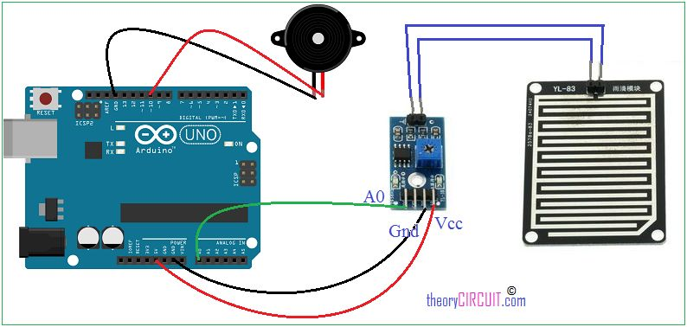

**Fig 3.1 SYSTEM ARCHITECTURE**

Raindrop sensor is basically a board on which nickel is coated in the form of lines. It works on the principal of resistance.

Rain Sensor module allows to measure moisture via analog output pins and it provides a digital output when a threshold of moisture exceeds.

The module is based on the LM393 op amp. It includes the electronics module and a printed circuit board that “collects” the rain drops.  As rain drops are collected on the circuit board, they create paths of parallel resistance that are measured via the data sent from the sensors are aggregated in the local base stations to provide inputs to the data processing centers.

**3.2 FEASIBILITY STUDY**

The feasibility of the project is analyzed in this phase and business proposal is put forth with a very general plan for the project and some cost estimates. During system analysis the feasibility study of the proposed system is to be carried out. This is to ensure that the proposed system is not a burden to the company. For feasibility analysis, some understanding of the major requirements for the system is essential.

Three key considerations involved in the feasibility analysis are

* ECONOMICAL FEASIBILITY
* TECHNICAL FEASIBILITY
* OPERATIONAL FEASIBILITY

**3.3.1 ECONOMICAL FEASIBILITY**

This study is carried out to check the economic impact that the system will have on the organization. The amount of fund that the company can pour into the Research and development of the system is limited. The expenditures must be justified. Thus the developed system as well within the budget and this was achieved

Because most of the technologies used are freely available. Only the customized products had to be purchased.

### 3.3.2 TECHNICAL FEASIBILITY

This study is carried out to check the technical feasibility, that is, the technical requirements of the system. Any system developed must not have a high demand on the available technical resources. This will lead to high demands on the available technical resources. This will lead to high demands being placed on the client. The developed system must have a modest requirement, as only minimal or null changes are required for implementing this system.

**3.3.3 OPERATIONAL FEASIBILITY**

The aspect of study is to check the level of acceptance of the system by the user. This includes the process of training the user to use the system efficiently. The user must not feel threatened by the system, instead must accept it as a necessity. The level of acceptance by the users solely depends on the methods that are employed to educate the user about the system and to make him familiar with it. His level of confidence must be raised so that he is also able to make some constructive criticism, which is welcomed, as he is the final user of the system.

**CHAPTER 4**

**SYSTEM SPECIFICATIONS**

**LAGUAGE SPECIFICATION**

This chapter describes the requirement analysis in accordance with the input and the resources and it also describes the implementation of the project with the technology used.

**REQUIREMENT ANALYSIS**

Requirement analysis determines the requirements of a new system. This project analyses on product and resource requirement, which is required for this successful system. The product requirement includes input and output requirements it gives the wants in term of input to produce the required output. The resource requirements give in brief about the software and hardware that are needed to achieve the required functionality.

**4.1 HARDWARE ENVIRONMENT**

The hardware requirements may serve as the basis for a contract for the implementation of the system and should therefore be a complete and consistent specification of the whole system. They are used by software engineers as the starting point for the system design. It shows what the systems do and not how it should be implemented.

* Hard disk : 120 GB
* Monitor : 15’ color with VGI card support
* Ram : Minimum 256 MB
* Processor : Pentium iv and above (or) equivalent
* Processor speed : Minimum 500 MHZ

**4.2 SOFTWARE ENVIRONMENT**

The software requirements are the specification of the system. It should include both a definition and a specification of requirements. It is a set of what the system should do rather than how it should do it. The software requirements provide a basis for creating the software requirements specification. It is useful in estimating cost, planning team activities, performing tasks and tracking the teams and tracking the team’s progress throughout the development activity.

* Operating system : Windows XP
* Languages : Java
* Data Base : Mysql
* IDE : aurdino 8.1

**IOT (INTERNET OF THINGS)**

## What is the Internet of Things?

In a nutshell, the Internet of Things is the concept of connecting any device (so long as it has an on/off switch) to the Internet and to other connected devices. The IOT is a giant network of connected things and people – all of which collect and share data about the way they are used and about the environment around them.

That includes an extraordinary number of objects of all shapes and sizes – from [smart microwaves](https://www.youtube.com/watch?v=1u4Mwn6BQyo), which automatically cook your food for the right length of time, to [self-driving cars](https://www.youtube.com/watch?v=K564rXrlZbc), whose complex sensors detect objects in their path, to wearable [fitness devices](https://www.ibm.com/blogs/internet-of-things/watson-iot-sports/) that measure your heart rate and the number of steps you’ve taken that day, then use that information to suggest exercise plans tailored to you. There are even [connected footballs](http://www.wilson.com/en-us/explore/football/wx.html) that can track how far and fast they are thrown and record those statistics via an app for future training purposes.

## How does it work?

Devices and objects with built in sensors are connected to an [Internet of Things platform](http://www.ibm.com/internet-of-things/), which integrates data from the different devices and applies

analytics to share the most valuable information with applications built to address specific needs.

These powerful IOT platforms can pinpoint exactly what information is useful and what can safely be ignored. This information can be used to detect patterns, make recommendations, and detect possible problems before they occur.

For example, if I own a car manufacturing business, I might want to know which optional components (leather seats or alloy wheels, for example) are the most popular. Using Internet of Things technology, I can:

* Use sensors to detect which areas in a showroom are the most popular, and where customers linger longest;
* Drill down into the available sales data to identify which components are selling fastest;
* Automatically align sales data with supply, so that popular items don’t go out of stock.

The information picked up by connected devices enables me to make smart decisions about which components to stock up on, based on real-time information, which helps me save time and money.

With the insight provided by advanced analytics comes the power to make processes more efficient. Smart objects and systems mean you can automate certain tasks, particularly when these are repetitive, mundane, time-consuming or even dangerous.

**PIC CONTROL BOARD**

* Adopts high quality of RF-04 double sided material.
* Area: 5cm x 4cm nickel plate on side,
* Anti-oxidation, anti-conductivity, with long use time;
* Comparator output signal clean waveform is good, driving ability, over 15mA;
* Potentiometer adjust the sensitivity;
* Working voltage 5V;
* Output format: Digital switching output (0 and 1) and analog voltage output AO;
* With bolt holes for easy installation;
* Small board PCB size: 3.2cm x 1.4cm;
* Uses a wide voltage LM393 comparator

**Advanced Analog Features:**

• 10-bit, up to 8-channel Analog-to-Digital Converter module (A/D) with:

- Conversion available during Sleep

- Up to 8 channels available

• Analog Comparator module:

- Programmable input and output multiplexing

• Comparator Voltage Reference module

• Programmable Low-Voltage Detection (LVD) module:

- Supports interrupt-on-Low-Voltage Detection

• Programmable Brown-out Reset (BOR)

**RAIN DROP SENSOR FEATURES**

* Operating voltage:**5V**
* Provide both **digital** and **analog output**
* **Adjustable sensitivity**
* Output **LED** indicator
* Compatible with **Arduino**
* **TTL** Compatible

**Buzzer Specifications**

• On-board passive buzzer

• On-board 8550 triode drive

• Can control with single-chip microcontroller IO directly

• Working voltage: 5V

• Board size: 22 (mm) x12 (mm)

**4.3 AURDINO EVOLUTION**

Arduino is an open-source electronics platform based on easy-to-use hardware and software. [Arduino boards](https://www.arduino.cc/en/Main/Products) are able to read inputs - light on a sensor, a finger on a button, or a Twitter message - and turn it into an output - activating a motor, turning on an LED, publishing something online. You can tell your board what to do by sending a set of instructions to the microcontroller on the board. To do so you use the [Arduino programming language](https://www.arduino.cc/en/Reference/HomePage) (based on [Wiring](http://wiring.org.co/)), and [the Arduino Software (IDE)](https://www.arduino.cc/en/Main/Software), based on [Processing](https://processing.org/)

Over the years Arduino has been the brain of thousands of projects, from everyday objects to complex scientific instruments. A worldwide community of makers - students, hobbyists, artists, programmers, and professionals - has gathered around this open-source platform, their contributions have added up to an incredible amount of [accessible knowledge](http://forum.arduino.cc/) that can be of great help to novices and experts alike

Arduino has been used in thousands of different projects and applications. The Arduino software is easy-to-use for beginners, yet flexible enough for advanced users. It runs on Mac, Windows, and Linux. Teachers and students use it to build low cost scientific instruments, to prove chemistry and physics principles, or to get started with programming and robotics. Designers and architects build interactive prototypes, musicians and artists use it for installations and to experiment with new musical instruments. Makers, of course, use it to build many of the projects exhibited at the Maker Faire, for example. Arduino is a key tool to learn new things. Anyone - children, hobbyists, artists, programmers - can start tinkering just following the step by step instructions of a kit, or sharing ideas online with other members of the Arduino community.

* **Inexpensive**
* Arduino boards are relatively inexpensive compared to other microcontroller platforms. The least expensive version of the Arduino module can be assembled by hand, and even the pre-assembled Arduino modules cost less than $50
* **Cross-platform**
* The Arduino Software (IDE) runs on Windows, Macintosh OSX, and Linux operating systems. Most microcontroller systems are limited to Windows.
* **Simple, clear programming environment** –
* The Arduino Software (IDE) is easy-to-use for beginners, yet flexible enough for advanced users to take advantage of as well. For teachers, it's conveniently based on the Processing programming environment, so students learning to program in that environment will be familiar with how the Arduino IDE works.
* **Open source and extensible software** –
* The Arduino software is published as open source tools, available for extension by experienced programmers. The language can be expanded through C++ libraries, and people wanting to understand the technical details can make the leap from Arduino to the AVR C programming language on which it's based. Similarly, you can add AVR-C code directly into your Arduino programs if you want to.
* **Open source and extensible hardware** -
* The plans of the Arduino boards are published under a Creative Commons license, so experienced circuit designers can make their own version of the module, extending it and improving it. Even relatively inexperienced users can build the [breadboard version of the module](https://www.arduino.cc/en/Main/Standalone) in order to understand how it works and save money

**DIAGRAM**

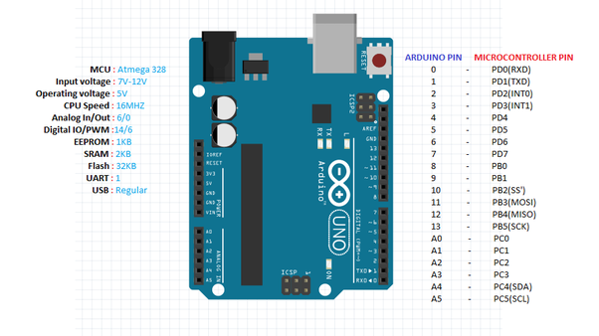

**4.3.1 PIN DIAGRAM**

### Pin Description

|  |  |  |
| --- | --- | --- |
| **Pin Category** | **Pin Name** | **Details** |
| Power | Vin, 3.3V, 5V, GND | Vin: Input voltage to Arduino when using an external power source.  5V: Regulated power supply used to power microcontroller and other components on the board.  3.3V: 3.3V supply generated by on-board voltage regulator. Maximum current draw is 50mA.  GND: ground pins. |
| Reset | Reset | Resets the microcontroller. |
| Analog Pins | A0 – A5 | Used to provide analog input in the range of 0-5V |
| Input/Output Pins | Digital Pins 0 - 13 | Can be used as input or output pins. |
| Serial | 0(Rx), 1(Tx) | Used to receive and transmit TTL serial data. |
| External Interrupts | 2, 3 | To trigger an interrupt. |
| PWM | 3, 5, 6, 9, 11 | Provides 8-bit PWM output. |
| SPI | 10 (SS), 11 (MOSI), 12 (MISO) and 13 (SCK) | Used for SPI communication. |
| Inbuilt LED | 13 | To turn on the inbuilt LED. |
| TWI | A4 (SDA), A5 (SCA) | Used for TWI communication. |
| AREF | AREF | To provide reference voltage for input voltage. |

### Arduino Uno Technical Specifications

|  |  |
| --- | --- |
| Microcontroller | [ATmega328P](https://components101.com/microcontrollers/atmega328p-pinout-features-datasheet) – 8 bit AVR family microcontroller |
| Operating Voltage | 5V |
| Recommended Input Voltage | 7-12V |
| Input Voltage Limits | 6-20V |
| Analog Input Pins | 6 (A0 – A5) |
| Digital I/O Pins | 14 (Out of which 6 provide PWM output) |
| DC Current on I/O Pins | 40 mA |
| DC Current on 3.3V Pin | 50 mA |
| Flash Memory | 32 KB (0.5 KB is used for Bootloader) |
| SRAM | 2 KB |
| EEPROM | 1 KB |
| Frequency (Clock Speed) | 16 MHz |

**CHAPTER 5**

**MODULES**

**5.1 MODULES**

* A modular design reduces complexity, facilities change (a critical aspect of software maintainability), and results in easier implementation by encouraging parallel development of different part of system. Software with effective modularity is easier to develop because function may be compartmentalized and interfaces are simplified. Software architecture embodies modularity that is software is divided into separately named and addressable components called modules that are integrated to satisfy problem requirements.
* Modularity is the single attribute of software that allows a program to be intellectually manageable. The five important criteria that enable us to evaluate a design method with respect to its ability to define an effective modular design are: Modular decomposability, Modular Comps ability, Modular Understandability, Modular continuity, Modular Protection.
* The following are the modules of the project, which is planned in aid to complete the project with respect to the proposed system, while overcoming existing system and also providing the support for the future enhancement.

**TYPES OF MODULES**

1. SERVER
2. HARDWARE SETUP

**5.2 MODULES DESCRIPTION**

**5.2.1 SERVER**

Server will establish the communication between the device and system. Through the hardware cable communication is executed between hardware kit and system. For every action server will response based the hardware performance.

**5.2.2 HARDWARE SETUP**

The analog output is used in detection of drops in the amount of rainfall. Connected to 5Vpower supply, the LED will turn on when induction board has no rain drop, and DO output is high. When dropping a little amount water, DO output is low, the switch indicator will turn on. Brush off the water droplets, and when restored to the initial state, outputs high level.When no rain digital output is 1 and analog output gives 1023 max value. When rain is present digital output is 0 and analogue output is much less than 1023. Using potentiometer on chip we can control the turning OFF point of digital pin at some value of analog pin.

**6. APPENDIX**

**6.1 SNAP SHOTS**

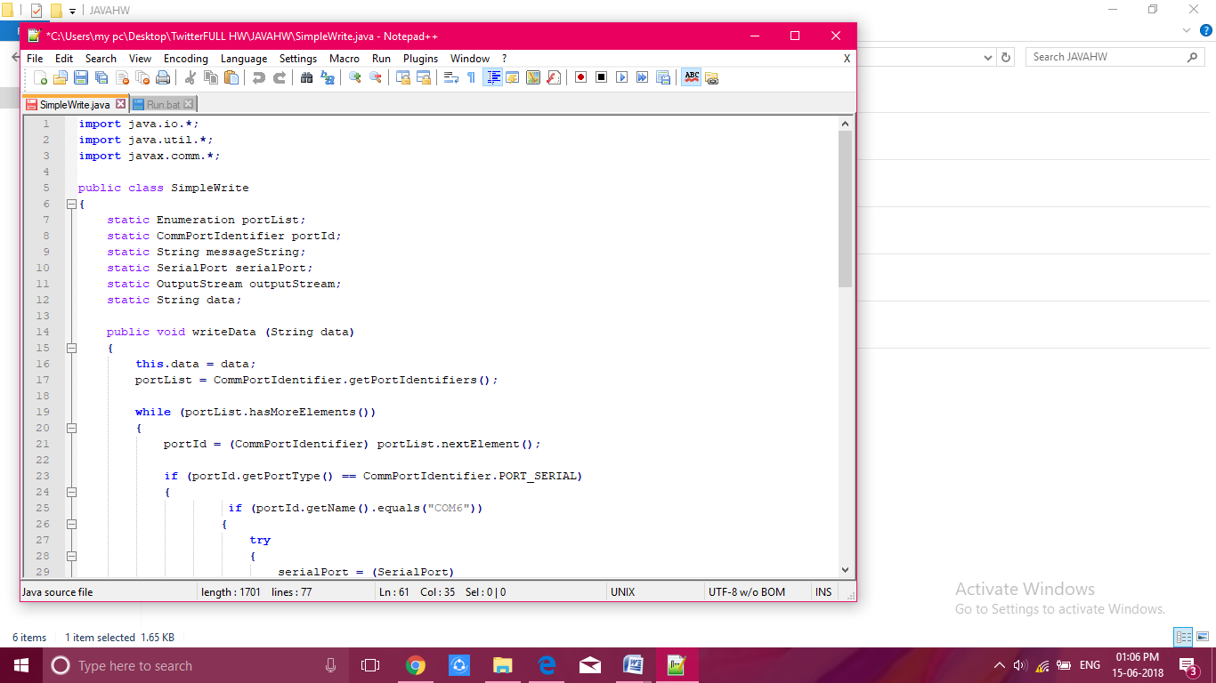

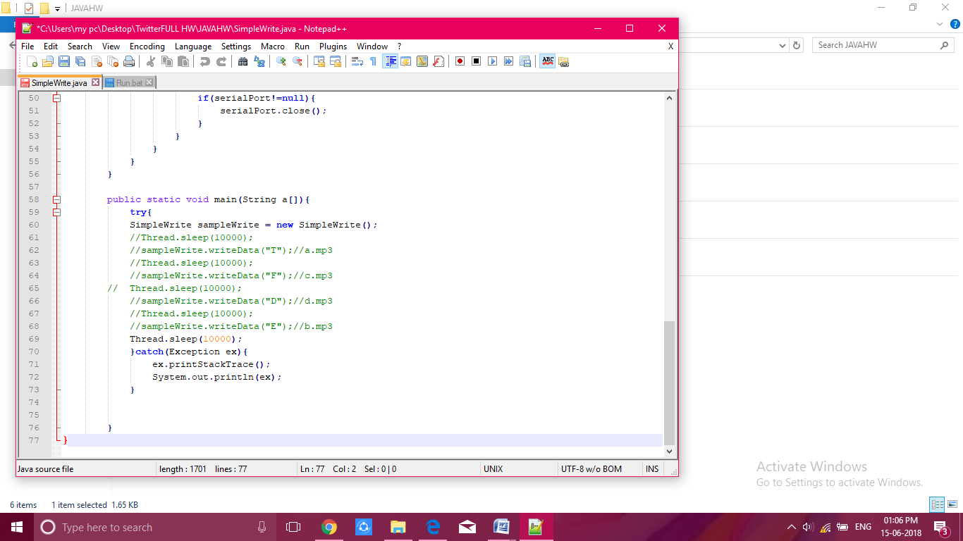

**6.1.1. Coding**

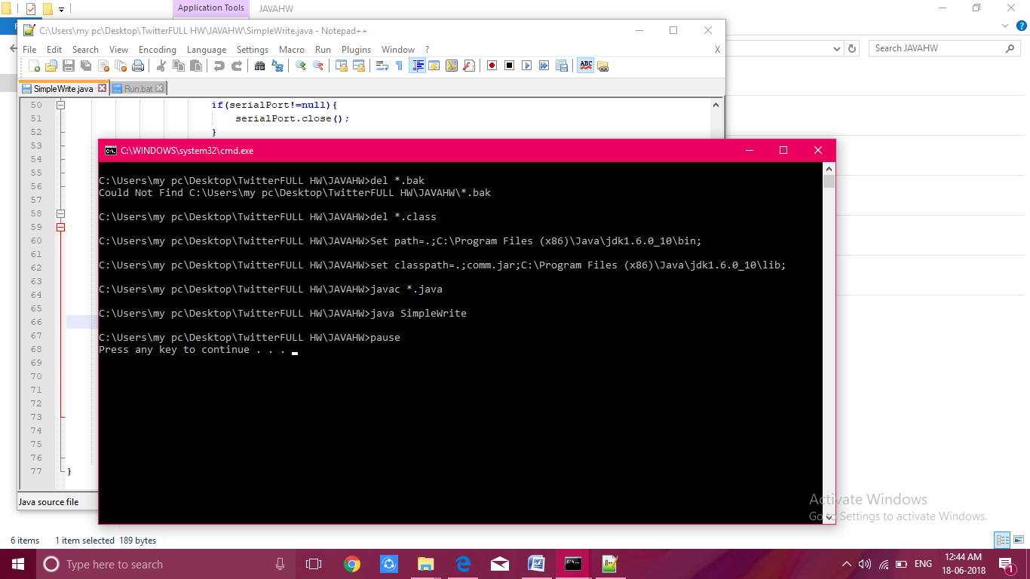

**6.1.2. Execution of program**

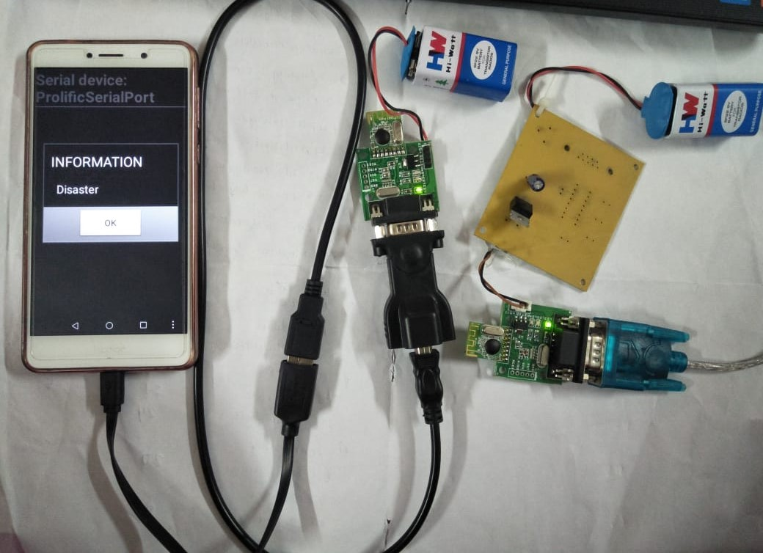

**6.1.3. Connection of devices**

**6.2 SOURCE CODE**

import java.io.*;

import java.util.*;

import javax.comm.*;

public class SimpleWrite

{

static Enumeration portList;

static CommPortIdentifier portId;

static String messageString;

static SerialPort serialPort;

static OutputStream outputStream;

static String data;

public void writeData (String data)

{

this.data = data;

portList = CommPortIdentifier.getPortIdentifiers();

while (portList.hasMoreElements())

{

portId = (CommPortIdentifier) portList.nextElement();

if (portId.getPortType() == CommPortIdentifier.PORT_SERIAL)

{

if (portId.getName().equals("COM6"))

{

try

{

serialPort = (SerialPort)

portId.open("SimpleWriteApp", 2000);

} catch (PortInUseException e) {}

try

{

outputStream = serialPort.getOutputStream();

} catch (IOException e) {}

try{

serialPort.setSerialPortParams(9600,

SerialPort.DATABITS_8,

SerialPort.STOPBITS_1,

SerialPort.PARITY_NONE);

}

Catch (UnsupportedCommOperationExceptione)

{}

try{

outputStream.write(data.getBytes());

}

catch (IOException e) {}

if(serialPort!=null){

serialPort.close();

}

}

}

}

}

public static void main(String a[]){

try{

SimpleWrite sampleWrite = new SimpleWrite();

//Thread.sleep(10000);

//sampleWrite.writeData("T");//a.mp3

//Thread.sleep(10000);

//sampleWrite.writeData("F");//c.mp3

//Thread.sleep(10000);

//sampleWrite.writeData("D");//d.mp3

//Thread.sleep(10000);

//sampleWrite.writeData("E");//b.mp3

Thread.sleep(10000);

}

catch (Exception ex){

ex.printStackTrace();

System.out.println(ex);

}

}

**7. CONCLUSION**

**CONCLUSION**

Thus the Paper Infer that there is a way to communicate with people without any network during disaster period. Through zigbee communication we communicate with the people. Embedded controlled sensor networks have proven themselves to be a reliable solution for natural disaster management systems. Three commercial sensors had been integrated with the system to monitor and compute the level of existence level sensor, accelerometer and temperature in atmosphere. This earthquake and tsunami alert systems senses earthquake waves, transmits these data to a base station via RF and from base station via GSM module and uses computer-based decision making to deliver alert signals to the identified receivers placed at different towns and cities for both public and government consumption.

**8. REFERENCES**

**REFERENCES**

[1] Vieweg, Sarah. ”Social Networking Sites : Reinterpretation in Crisis Situations.”

CSCW 2008 Workshop on Social Networking in Organizations.

2008.

[2] White, Eritc T. “The Application of Social Media in Disasters How CanSocial Media Support an Effective Disaster Response?” (2014)

[3] Lindsay, Bruce R . ”Social media and disasters: Current uses, futureoptions, and policy considerations.” (2011).

[4] Chapter 1 and 5. World Disaster Report (2013). http://worlddisastersreport.Org /en /.

[5] Quintanilla, J. ‘Disaster communications: covering the “last mile”’in The Guardian, 3 April 2013. Available online: www.guardian.co.uk/global-development-professionals-network/2013/ apr /03/ disaster communications-ict-internews.